Monochromatic | Analogous | Complementary
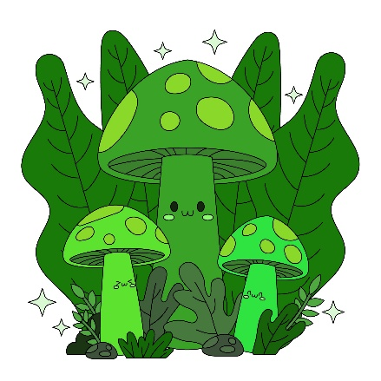 | 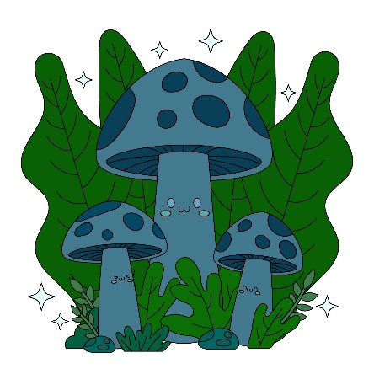 | 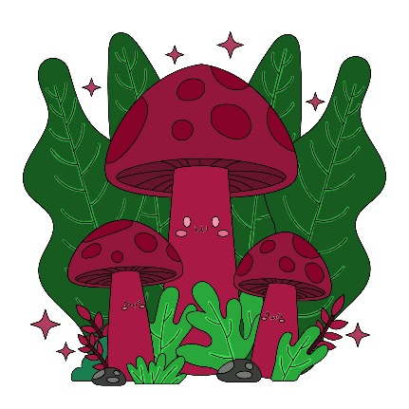
Greens | Greens/Blues | Greens/Blues/Maroons
Colour Scheme | How does this colour scheme impact mood? | How does this colour scheme impact emotion? | How does this colour scheme impact the message?
Monochromatic | Boring but calm and nature because all the tones draw from a single green family | Boring and dull but properly due the lack of other colours | Conveys a clean, unified environmental harmony and nature.
Complementary | Bold, vibrant, warm and energetic mood using contrasting red and green elements. | More warmly appeiling due to variety of colours and shades but they blend well together. | Draws immediate attention to the main subject, making the message punchy and memorable.
Analogous | A smooth, comfortable, and unified atmosphere as the neighboring blue and green hues blend naturally. | The shades and tones of blue and green hues give a forgetable but quite vibe | Deliver natural closeness, and peaceful coexistence between the forest background and subjects.

